GIYC Day Race
Grosse Ile Yacht Club
29677 East River Road
Grosse Ile, Michigan 48138
May 25, 2024
NOTICE OF RACE
- Rules and Management
  - This race will be under the management Grosse Ile Yacht Club Race Committee, which will have full and final authority in establishing the race articles and in interpreting the rules.
  - The RACING RULES of SAILING (RRS), and the prescriptions of the US SAILING, except as modified by this program, will govern.

- Entry and Eligibility
  - The race is open to all boats that have been issued a current PHRF Certificate.
  - Eligible boats may enter by signing up on the Notice of Race website www.noticeofrace.net and uploading a copy of their race entry form, valid PHRF certificate, and proof of insurance. Electronic copies may also be emailed to race@giyc.com. Hand written entry forms will be accepted up to the entry deadline as stated below. Hand written applications shall be delivered to Grosse Ile Yacht Club office at the address listed above on or before the entry deadline.
  - Entry deadline is 21:00 on May 24th 2024. Late entries may be accepted at the discretion of the Race Committee.
  - Entry fees shall be made payable to Grosse Ile Yacht Club no later than the Skipper’s Meeting as shown in the Schedule below. GIYC members may pay via their club account. All others are encouraged to pay by check.
- Fees
  - Required entry fee is $35.

- Schedule

  - Registration May 25th 09:00 at the Skipper’s Meeting
  - All participants are encouraged to attend the Skipper’s Meeting at GIYC 09:00 May 25th, 2024
  - Approximate time of the first Warning is 10:55.
  - Afterglow will be located at Grosse Ile Yacht Club following the race.

- Measurement

  - Each boat shall produce a valid PHRF certificate. Lake Erie PHRF ratings will be used for handicapping purposes.

- Sailing Instructions

  - The Sailing Instructions will be posted on the Notice of Race website on or before the Skipper’s meeting on May 25th. https://noticeofrace.net/eventpage.aspx?&ID=1206
  - Limited hard copies of the Sailing Instructions will be available at the Skipper’s Meeting however, participants are encouraged to download their own copy in advance to reduce waste.

- Venue and Courses
Start Area
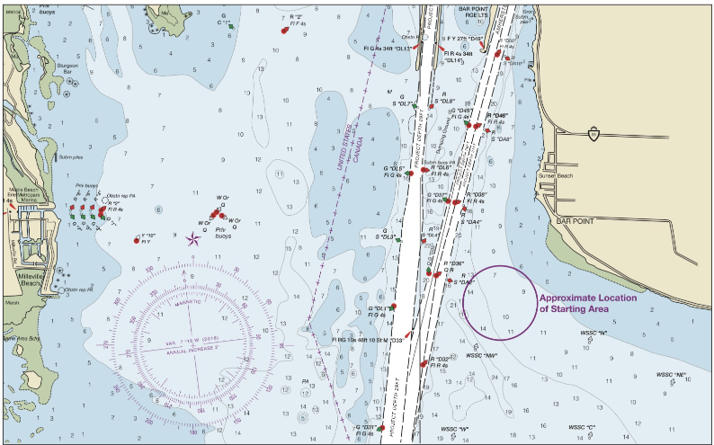
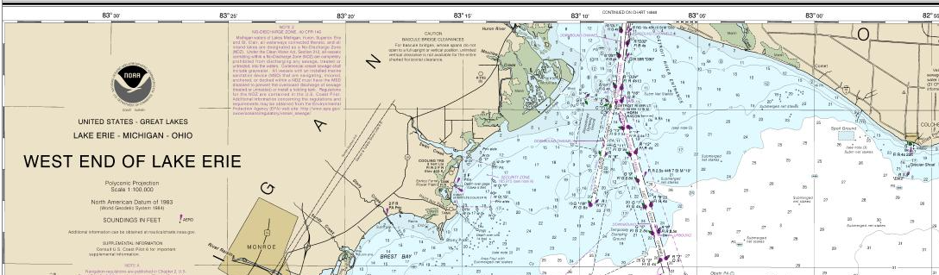
Chart 14830

  - The course will utilize private and fixed Government marks, starting near the West Shore Sail Club WNATR buoys located near the mouth of the Detroit River.
  - Race distance will be between 12-28 NM based on prevailing wind conditions forecast at the time of the Skipper’s Meeting.

- Penalty System

  - RRS 44.1 is changed so that the Two-Turns Penalty is replaced by the One-Turn penalty.

- Scoring RRS 90.3

  - There will be one race only.
  - Scoring will be determined in accordance with RRS Appendix A. Time allowances for boats will be calculated, Time on Distance, in accordance with the boat’s PHRF Lake Erie Rating.

- Radio Communication

  - Courtesy broadcasts by the Race Committee Boat will be on VHF Channel 71

- Classes to Race

  - Classes may include Jib and Main (JAM) and Spinnaker.
  - A minimum of 3 entries are required per class.
  - Each class will be subdivided based on PHRF handicaps and the number of competitors registered. A scratch sheet with class subdivisions will be published on the Notice of Race website on or before 09:00 on May 25th.

- Prizes

  - Flags will be awarded at the GIYC Awards Night in the fall.
  - Results of the race will be announced at the afterglow the day of the race.

- Disclaimer of Liability

  - RRS 3 states: ‘The responsibility for a boat’s decision to participate in a race or to continue to race is hers alone.’ By participating in this event each competitor agrees and acknowledges that sailing is a potentially dangerous activity with inherent risks. These risks include strong winds and rough seas, sudden changes in weather, failure of equipment, boat handling errors, poor seamanship by other boats, loss of balance on an unstable platform and fatigue resulting in increased risk of injury. Inherent in the sport of sailing is the risk of permanent, catastrophic injury or death by drowning, trauma, hypothermia or other causes.

- Insurance
  - Each participating boat shall be insured with valid third-party liability insurance with a minimum cover of $300,000 per incident or the equivalent.

- Further Information
  - For further information please contact: Michael Fluegemann, 734-751-5513, race@giyc.com

